Unity was built to use its own version control system but those features are locked behind the pro license. Unity projects can be version controlled using git however there are some things that must be kept in mind to avoid issues.

- Close unity, mono develop, and visual studio before you interact with Git

Unity constantly modifies files while it is open and having two programs modifying the file at the same time can cause issues

Not doing this can cause files to appear full of code in the dev environment but empty on the commit, work pulled from the repo to disappear/be overwritten with the running build, or corrupted files.

- Work with Git not against it

Don’t lose your work. Every time you commit something to the remote repo or pull from the remote repo you must follow this order.

  - Commit (Store changes locally)
  - Pull (Get remote changes)
  - Test (Things from the server may break your build or vise-versa)
  - Commit Again (Store changes locally to save and fixes from the tests if there were any)
  - Push (Give it to the rest of your team)

Not following this order may make it seem like Git is deleting your work. Pulling without committing first is allowing Git to overwrite your work with what is on the server.

- You must resolve conflicts

When the same file was modified on both the local and the remote repo you will get a conflict. You can resolve conflicts by either doing full “Keep my changes”, “Keep their changes”, or right clicking on the conflicted file and selecting edit conflicts.

TortoiseGit has a conflict manager that can resolve conflicts on text files and it allows you to select what blocks of code you want to keep from your file, what block you want to keep from their file, and writing a new line that does both. It is very useful.

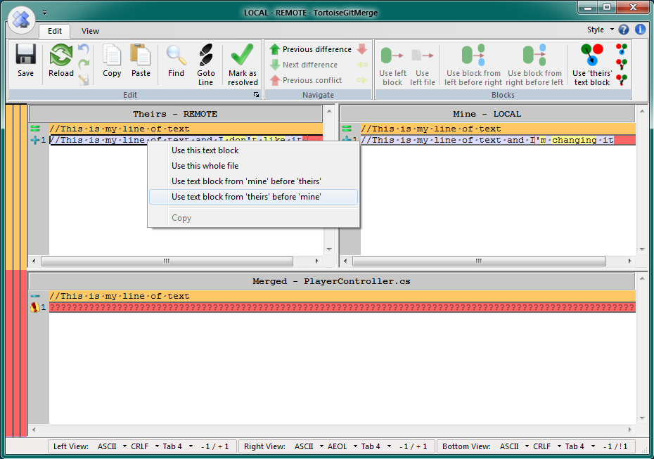

- Binary files and Git don’t play well with each other

Git is intended to be used with text based formats. Binary files cannot be merged with Git. This includes scenes, prefabs, textures, sounds, music… anything not in a text based format.

When a conflict occurs with binary files the only resolution options available are “Keep my changes” and “Keep their changes”. Because of this it is important that only one person work on a binary file at a time. Communicate with team members and use spike solutions (other game scenes) while working to avoid this.

